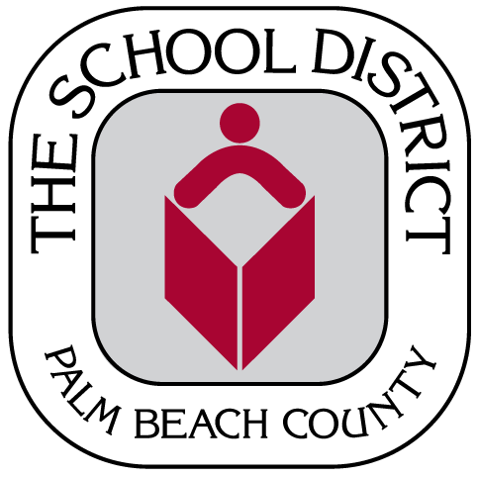
Title I Parents’ Right to Know Notification Verification
2019-2020

TO: Department of Federal and State Programs

FROM: ___________________________________________________________

SCHOOL: ___________________________________________________________

DATE: ___________________________________________________________

SUBJECT: DISTRIBUTION OF 2019-2020 TITLE I PARENTS’/GUARDIANS’ RIGHT TO KNOW LETTERS

This verifies that the Title I Parents’ Right to Know letters were sent home with students to all parents in the appropriate languages in accordance with the requirements of the Every Student Succeeds Act [Section 1112(e)(1)(A)].

It is considered best practice to communicate with families utilizing at least three methods.
I am providing supporting evidence to certify that the Parents’ Right to Know letters have also been shared through: (check all that apply)

US mail School website

Email Student handbook

Daily planner/agenda School calendar

School newsletter Student registration “Back to School” event/Parent meeting Other _______________________

Other methods were not used.

Principal Signature: _______________________________ Date: ______________
(Blue ink, please)

Submit verification and evidence of all methods of distribution via Pony or email* no later than Friday, August 30, 2019 to:

Melissa Shea
melissa.shea@palmbeachschools.org
Department of Federal and State Programs FHESC, Suite B-102

*Scanned copy must be in color

